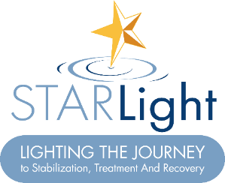
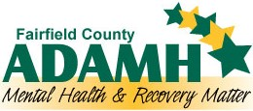

FOR IMMEDIATE RELEASE: February 29, 2024
Contact: Jackie Howard, Public Relations Coordinator, Fairfield County ADAMH, jhoward@fairfieldadamh.org

Fairfield County ADAMH Board and OhioGuidestone Celebrate STARLight Center Ribbon Cutting
LANCASTER, Ohio – The Fairfield County Alcohol, Drug Addiction and Mental Health (ADAMH) Board and OhioGuidestone held an open house of the STARLight Center, lighting the journey to stabilization, treatment and recovery, on February 29, 2024. The STARLight Center fulfills a promise to the community to provide a safe, welcoming place where residents can receive immediate help for mental health and substance use crises. This is the first and only facility of its kind in Fairfield County.
Since its groundbreaking in May 2022, ADAMH has fervently prepared for the center’s inpatient services, housing up to 20 people seeking immediate support. The STARLight Center, located at 336 E. Locust Street in Lancaster, was formed as a response to the 2019 tax levy. Voters voiced a need for more accessible mental health and substance use care in Fairfield County.
“We’re thrilled to see the STARLight Center come to fruition,” said Marcy Fields, Executive Director of ADAMH. “It has been a collective effort to fulfill this community promise for a safe and stable center. I’m overwhelmingly appreciative of the support from so many in our community, and I’m eager to start helping those who need these services.”
The STARLight Center will officially welcome patients beginning late spring. The providing agency, OhioGuidestone, is supplying 24/7 care to patients who have a three to five day stay for mental health conditions, and up to 30 days for those battling substance use.
“Today marks a new chapter in behavioral health care as STARlight becomes OhioGuidestone’s first adult mental health crisis stabilization program in Central Ohio,” said President and CEO of OhioGuidestone, Brant Russell. “Each of the beds here represents a life that will change for the better, and the hope that a brighter future is possible.”
Amanda Wattenberg, Vice President of Regional Operations at OhioGuidestone echoed these sentiments: “Whether it’s outpatient care or residential treatment, OhioGuidestone's commitment to the community of Fairfield County is to provide a safe, compassionate and respectful haven to help adults through the most difficult times of their lives. The STARlight center will be a place of healing and new beginnings.”
About ADAMH
The Fairfield County ADAMH Board is responsible for the planning, funding and monitoring of mental health, addiction and recovery services in Fairfield County. ADAMH promotes wellness and recovery from mental health and substance use disorders by providing a continuum of care consisting of prevention, recovery and community support services for those affected by substance use disorders and/or mental health disorders in Fairfield County. For more information, visit www.fairfieldadamh.org.

About OhioGuidestone
As Ohio’s leader in community behavioral health care, we focus on the needs of the whole person, empowering them to take steps towards a healthier future. Our mission is guided by a set of core values: Faith, Integrity, Trust, Compassion, and Hope.
###
108 W. Main Street, Suite A, Lancaster, Ohio 43130 • Voice/TDD 740.654.0829 • Fax 740.654.7621
www.fairfieldadamh.org • Equal Opportunity Employer and Equal Provider of Services

